**Week of:** **The Big Give: Get Wrapped Up in Christmas – Week 3** **Preteen**

**December 18, 2022**

**Today’s Bible Story:** The Greatest Gift (Jesus Is Born) • *Luke 2:1-7*

**Today’s Key Question:** What are you excited about giving?

**Today’s Bottom Line:** Jesus is the greatest gift

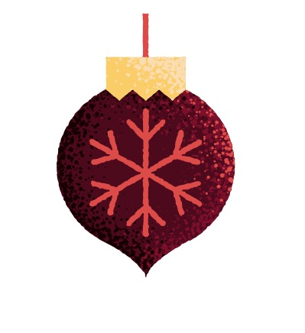**Monthly Memory Verse:** *Today in the town of David a Savior has been born to you. He is the Messiah, the Lord.* Luke 2:11 *(NIrV)*

**Monthly Virtue:** Christmas—Celebrating Jesus, God's greatest gift

**Basic Truth:** I can trust God no matter what.

**Activity:** Christmas Letter

**What you need:** Paper and coloring supplies

**(After the Video) What You Do:**

* Invite your child to make a card for a family member they will see this week or next.
* Encourage them to write a personal note to that relative, showing appreciation for their love and help.
* Talk with your child about your families plans for Christmas.



**Ask:**

* + “Is there anything special you would like to do to celebrate Christmas this year?”
  + “Who makes the best Christmas treat in our family?”
  + “What is your favorite holiday tradition?”
  + “What’s the greatest gift you’ve ever been given?”
  + “What do you like about giving someone a gift?”
  + “Why is Jesus the greatest gift to us?”

**What You Say:**

* Explain that Christmas time is always a reminder that Jesus is the greatest gift we’ve ever been given. The festivities and excitement of the Christmas season are such a special way to remember that. But the gift God gave us is so much more than just a season! It’s a gift that lasts forever.

**Prayer:**

“Thank You, God, for giving us the greatest gift. You loved us so much that You sent Your only Son to be our Rescuer—to save us so we could be part of Your family forever. Thank You for giving us such an amazing reason to celebrate at Christmas. In the middle of our busy day on Christmas, remind us to take a moment to thank You for all You have given us. We love You, and we pray these things in Jesus’ name. Amen. ***[Bottom Line]* Jesus is the greatest gift.”**

